|  |  |
| --- | --- |
| Sample Arguments - What is the mystery powder? | |
| Example 1 | **Example 2** |
| We observed that our mystery powder:   * Dissolved in water without making it cloudy, like baking soda and flour * Did not turn black when iodine was added, like flour did * Had large, rough crystals that were a similar shape to the salt sample and different from the sugar sample * Did not rub into the skin like flour or powdered sugar   If two powders share the same properties, then they are likely the same kind of powder. Our mystery powder shared had properties that were similar to salt, and different from the other powder samples. Because of this, we think the mystery powder is salt. | Our mystery powder dissolved in water and didn’t turn black when iodine was added. Because of this the mystery powder is not flour. |

**Appendix A**

|  |  |
| --- | --- |
| What makes a good argument? | |
| A strong argument… | **A weak argument…** |
| * Makes a claim that answers the question * Uses data to support the claim * Considers all the available evidence * Connects the evidence to the claim (provides reasoning) * Provides enough detail for others to evaluate the evidence and decide whether they agree with the claim | * Ignores data that doesn’t support the claim * Relies on limited data * Does not connect the data to the claim * Does not provide enough information for others to decide whether they agree with the claim |

**Appendix B**

**Integrated STEM Unit 1**

**Short-Term and Long-Term Weather**

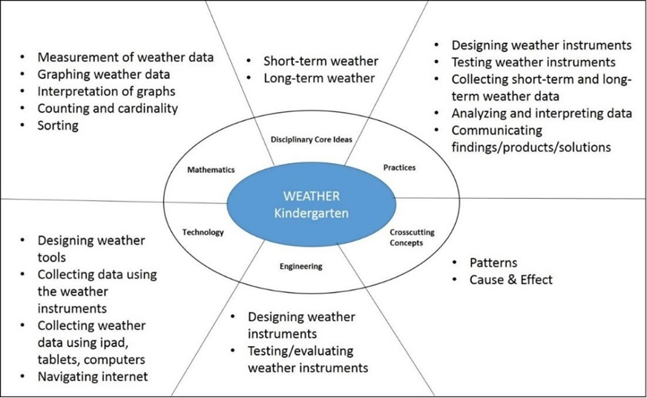

|  |  |
| --- | --- |
| **Science** | |
| NGSS | Lesson |
| **Disciplinary Core Ideas**  ESS2 – Earth’s Systems  ESS2.D – Weather & Climate Weather is the combination of sunlight, wind, snow or rain, and temperature in a particular region at a particular time. People measure these conditions to describe and record the weather and to notice patterns over time. (K-ESS2-1) | Lesson 1 – Measuring Weather with Weather instruments  Lesson 2: Testing locations to find the best place for the weather instruments  Lesson 3: Using weather instruments to investigate short-term & long term weather. |
| **Cross Cutting Concepts**  Patterns  Patterns in the natural world can be observed, used to describe phenomena, and used as evidence. (K-ESS2-1) | Lesson 3: Using weather instruments to investigate short-term & long term weather. |
| **Science & Engineering Practices**  Asking Questions and Defining Problems Asking questions and defining problems in grades K–2 builds on prior experiences and progresses to simple descriptive questions that can be tested. Ask questions based on observations to find more information about the designed world. (K-ESS3-2)  Planning and Carrying Out Investigations Planning and carrying out investigations to answer questions or test solutions to problems in K–2 builds on prior experiences and progresses to simple investigations, based on fair tests, which provide data to support explanations or design solutions. Make observations (firsthand or from media) to collect data that can be used to make comparisons. (K-PS3-1)  Analyzing and Interpreting Data  Analyzing data in K–2 builds on prior experiences and progresses to collecting, recording, and sharing observations.  Use observations (firsthand or from media) to describe patterns in the natural world in order to answer scientific questions. (K-ESS2-1)  Constructing Explanations and Designing Solutions  Constructing explanations and designing solutions in K–2 builds on prior experiences and progresses to the use of evidence and ideas in constructing evidence-based accounts of natural phenomena and designing solutions. Use tools and materials provided to design and build a device that solves a specific problem or a solution to a specific problem. (K-PS3- 2)  Obtaining, Evaluating, and Communicating Information  Obtaining, evaluating, and communicating information in K–2 builds on prior experiences and uses observations and texts to communicate new information. Read grade-appropriate texts and/or use media to obtain scientific information to describe patterns in the natural world. (K-ESS3-2) | Lesson 1 – Measuring Weather with Weather instruments  Lesson 3: Using weather instruments to investigate short-term & long term weather.  Lesson 2: Testing locations to find the best place for the weather instruments  Lesson 3: Using weather instruments to investigate short-term & long term weather.  Lesson 2: Testing locations to find the best place for the weather instruments  Lesson 3: Using weather instruments to investigate short-term & long term weather.  Lesson 1 – Measuring Weather with Weather instruments  Lesson 2: Testing locations to find the best place for the weather instruments  Lesson 3: Using weather instruments to investigate short-term & long term weather.  Lesson 1 – Measuring Weather with Weather instruments  Lesson 2: Testing locations to find the best place for the weather instruments  Lesson 3: Using weather instruments to investigate short-term & long term weather. |
| **Connections to Nature of Science** Scientific Investigations Use a Variety of Methods  Scientists use different ways to study the world. (K-PS3-1)  Science Knowledge is Based on Empirical Evidence  Scientists look for patterns and order when making observations about the world. (K-ESS2-1) | Lesson 2: Testing locations to find the best place for the weather instruments  Lesson 3: Using weather instruments to investigate short-term & long term weather. |

|  |  |
| --- | --- |
| Engineering | |
| NGSS |  |
| **ETS1.A: Defining and Delimiting an Engineering Problem**  Asking questions, making observations, and gathering information are helpful in thinking about problems. (secondary to K-ESS3-2)  **Connections to Engineering, Technology, and Applications of Science** Interdependence of Science, Engineering, and Technology - People encounter questions about the natural world every day. (K-ESS3-2)  Influence of Engineering, Technology, and Science on Society and the Natural World: People depend on various technologies in their lives; human life would be very different without technology. (K-ESS3- 2) | Lesson 1 – **Measuring Weather with Weather instruments** |

|  |  |
| --- | --- |
| Mathematics | |
| Common Core |  |
| MP.2 Reason abstractly and quantitatively. (K-ESS2-1)  MP.4 Model with mathematics. (K-ESS2-1),(K-ESS3-2)  K.CC Counting and Cardinality (K-ESS3-2)  K.CC.A Know number names and the count sequence. (K-ESS2-1)  K.CC.B. Count to tell the number of objects  K.MD.A.1 Describe measurable attributes of objects, such as length or weight. Describe several measurable attributes of a single object. (K-ESS2-1)  K.MD.A.2 Directly compare two objects with a measurable attribute in common, to see which object has “more of”/”less of” the attribute, and describe the difference. (K-PS3-1),(KPS3-2)  K.MD.B.3 Classify objects into given categories; count the number of objects in each category and sort the categories by count. (K-ESS2-1) | Lesson 2: Testing locations to find the best place for the weather instruments  Lesson 3: Using weather instruments to investigate short-term & long term weather.  Lesson 3: Using weather instruments to investigate short-term & long term weather.  Lesson 3: Using weather instruments to investigate short-term & long term weather.  Lesson 3: Using weather instruments to investigate short-term & long term weather.  Lesson 2: Testing locations to find the best place for the weather instruments  Lesson 1 – Measuring Weather with Weather instruments  Lesson 3: Using weather instruments to investigate short-term & long term weather.  Lesson 1 – Measuring Weather with Weather instruments  Lesson 3: Using weather instruments to investigate short-term & long term weather.  Lesson 3: Using weather instruments to investigate short-term & long term weather. |

**Lesson 1 –** **Measuring Weather with Weather instruments**

* Mathematics: Measurement
* Science: Weather instruments
* (Engineering &) Technology: Building weather instruments

Students will determine what is considered hot, cold, warm, cool, etc.; how to determine what evidence will tell them the wind speed (slow or fast), how to measure the amount of precipitation.

They will build their own instruments. **(They will determine what evidence they will use for each)**

**Mathematics**

**Measuring Temperature**

Children will develop skills in measuring temperature and communicating the changes in the temperature using the terms “less than” or “greater than.” They will also identify the temperature values as “cold,” “hot,” or “warm.”

Materials: Classroom thermometers for each student pair and a journal, cups of water with varying temperature values.

**Procedures**:

Show a thermometer to the students and tell them that they will be using thermometers to practice with number. They will be using their knowledge of numbers and counting to decide which of the temperature values is greater or less than the other. Practice the “greater than” and “less than” with numbers and number stories.

|  |  |  |
| --- | --- | --- |
| Sign | Name of the Sign |  |
| **<** | Less than | When one number is smaller than another  3 < 9 |
| **>** | Greater than | When one number is greater than another  5 > 1 |
| **=** | Equal to | When two numbers are the same  8 = 8 |
| **≠** | Not equal to | When two numbers are NOT the same  2 ≠ 4 |

To remember which way around the “<” and “>” signs go, provide the below trick to the students.

BIG > small

small < BIG

Examples: 9 is **greater than** 2 so we show this sentence as 9 > 2

3 is **less than** 7 and we show that as 3 < 7

Practice Questions: express the following sentences mathematically using the “less than” and “greater than” signs. Have students practice with the following expressions until they are done on their own. Check everyone’s answers to make sure that everyone has accomplished this task.

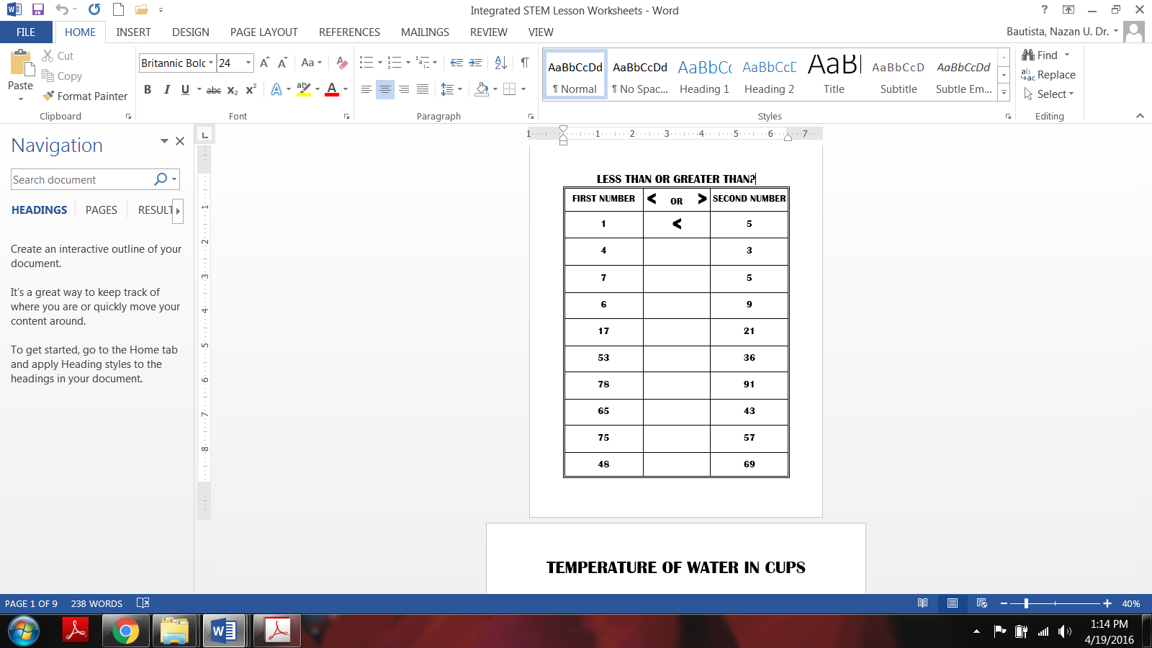

Now that students worked with the single and double digit numbers using less than and greater than symbols, have them practice the same concept using a thermometer and reading the temperature values. Pair up students and provide a thermometer to each pair. Let them make observations about the instrument. Ask them to share their observations (e.g., numbers, lines, red line inside the glass, etc.) Ask students what they notice about the order of the numbers (anticipation is that they would notice the numbers in an order highest being on top and the lowest being at the bottom. Explain to the students that these numbers refer to the temperature values. They tell us how hot or cold and object (or air) is. The red liquid inside goes up or down depending on the temperature of the object (or air) we are measuring. Provide cups of cold water to each of the pairs and ask students to place their thermometers inside the water (and do not identify the water as “cold water” yet) and start making careful observation about the motion of the red liquid as soon as the thermometer is in the water. Ask students to wait until the red liquid stops moving and then check the number where it stops/rests. Assist students while reading the temperature value. After everyone records the temperature explain to students that the number they read is the temperature of the water. To help them understand the concept of temperature better, provide 2 additional cups of water (preferably identical cups and amounts of water) with differing temperatures. For instance:

**80 C**

**40 C**

**10 C**

Place a thermometer in each of the cups and ask students to repeat the same process (reading the temperature values).

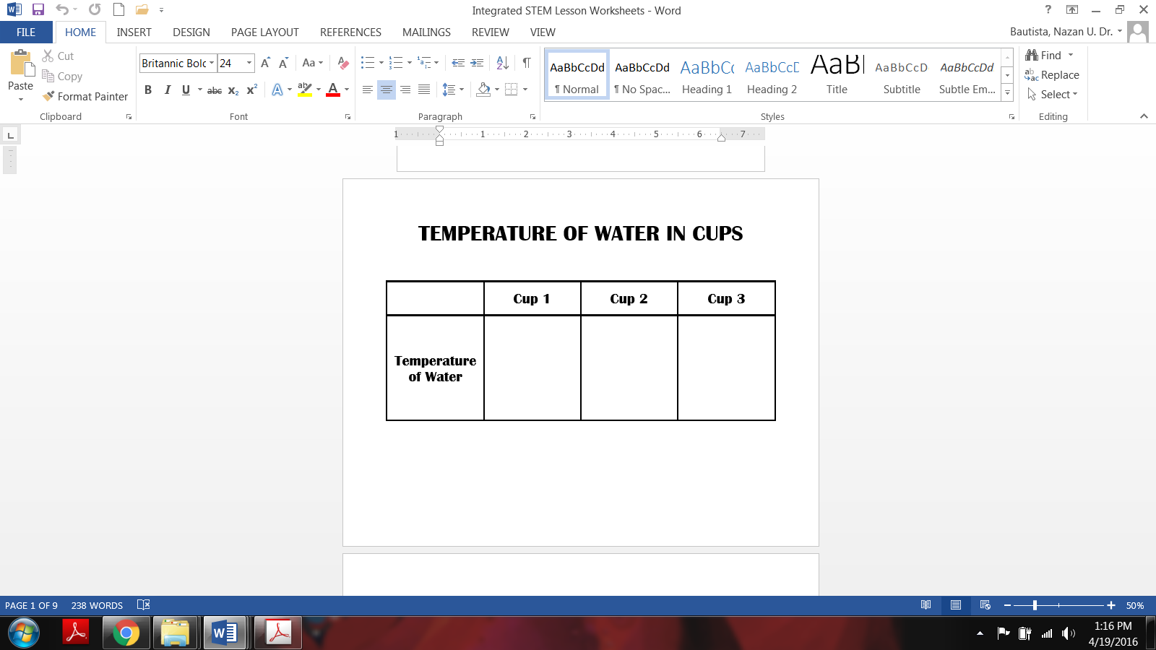

After organizing their temperature values with a table, ask students use their mathematical knowledge about “less than” and “greater than” to compare the recorded temperature values. For instance, students should state “10 is less than 40” or “80 is more than 40” etc.

Ask students what these numbers may mean. Why some are lower or higher than others? Students may or may not associate these values with the warmness of the water in cups. After their predictions allow them to touch the water in each up using their fingers. Ask them to describe what they feel. Anticipated response: Cup 1 feels cold or colder than others, etc. Guide students to order the degree of warmness they feel with their senses (cup 1 feeling the coldest and cup 3 feeling the warmest). Then help them associate the numeric value of the temperature with the sense of coldness and warmth. In other words, lower numbers refer to cooler temperatures and higher numbers refer to warmer temperatures. Finally, conclude that the temperature tells us how hot/warm or cold the water is.

Practice questions:

Once students are comfortable using thermometers, ask what other things they can measure with a thermometer or where else they can use thermometer. Teacher can show a weather report videos or audio recording to help them see that temperature is one of the variables we use to describe the weather. This understanding can be supported by asking students to measure the outside temperature early in the morning, at noon, and in the afternoon. While recording the temperature values, teacher can guide students to describe how warm or cold they feel and associate the temperature values to the warm or cold weather. This will also support and confirm the previous activity with water.

**Lesson 2:** **Testing locations to find the best place for the weather instruments**

Materials: Thermometers, rain gauges, observation charts, graphing charts, and weather pictures.

Ask students, “What instruments do you or your family members use to measure weather? What instruments do scientists use to measure weather? Students will likely be able to name a thermometer, but they may not be able to name any other instruments that measure weather. Explain to students that there are many more tools scientists use to measure weather. They even use their eyes as important instruments for measuring visibility and making observations.

Obtain examples of the actual weather instruments, such as rain gauge, wind vane, anemometer, barometer, thermometer, etc., from the school science lab or other teachers (or Carolina.com). Tell students that these are the tools used to talk about weather and measure weather variables such as precipitation (how much it rained or snowed), and temperature (how warm or cold the air is). Allow students to touch and examine each instrument. Tell them what each instrument is called and ask them to describe how they believe it works. Do not state what it measures. Ask students to predict what weather variable each instrument measures. Provide an example, such as “We used thermometer to measure the temperature of a cup of water before so we can then use thermometer to measure the temperature of the air outside.” After students develop their own theories as to how each instrument works and what it might be used for, teacher explains the purpose of each tool and what variable they measure.

**Alternative:** If you do not have the real instruments, display the photo gallery Instruments That Measure Weather. Cover the names of the instruments and the captions with a piece of blank paper. Describe what each instrument is and how it works, without stating what it measures. Have students raise their hands to tell what “weather variable” the instrument measures. For example:

* Display the photo of an **anemometer**. Point out that it is a stick with a rotating x on the top. At the tips of the x are little cups that catch moving air. When the air moves a lot, the cups spin the x around quickly. Elicit from students that the instrument measures wind.
* Display the photo of a **snow/rain gauge**. Point out that the tall cylinder is left out in the weather and fills with snow or water. Elicit from students that the instrument measures rain or snow.
* Display the photo of a **thermometer**. Point out that the long, thin tube is filled with mercury. Heat makes the mercury expand and it rises up the tube. Elicit from students that the instrument measures hot and cold temperatures.
* Display the photo of a **barometer**. Point out that it looks like a thermometer, but it moves up when the air is lighter and down when it is heavier. Elicit from students that the instrument measures air pressure.

Understanding how to use weather instruments to investigate long & short-term weather requires students to also understand the best locations for each instrument to ensure reliability of the data. Reliability information can be explained as “accuracy” of the information to gain others’ trust. On a side note, since the grade level is Kindergarten, the standards only focus on “temperature, precipitation, wind and sky coverage” we will only use thermometer, rain gauge, anemometer, and wind sock for this part of the lesson. It is also important to note that students will be asked to describe if the wind is fast or slow by making observation of the anemometer arms’ movement.

Ask students, “Where should we place the instruments to have the best data?”

To keep this part of the instruction and the classroom under control, ask students to provide their predictions for each instrument individually. For example, hold the thermometer up and ask “Where do you think we need to place this outside so that we can accurately measure the outside temperature?” If you want to make the inquiry more structured, you can provide options for students and limit their choices. For example, hold the thermometer up and ask “Where do you think we should place the thermometer, in the shade of a tree or a building or in an open area where the sun is not blocked by anything so we can accurately measure the outside temperature?”

Only have 1 investigation station for each weather instrument. Teacher can either put students in small groups then assign a weather instrument to each of the groups or this part can be done collectively by teacher guiding the students.

*Thermometer:* Provide two thermometers to the student group who will be investigation the best location for thermometer. Students will select two locations; one in the shade throughout the day and the other in an open area. Students will place the thermometers in similar positions at both locations. Students will measure the temperature value on each instrument several times a day (e.g., early morning, noon and late afternoon). Students will also use the weather app to check the official temperature data recorded and publicly shared by the local meteorologists.

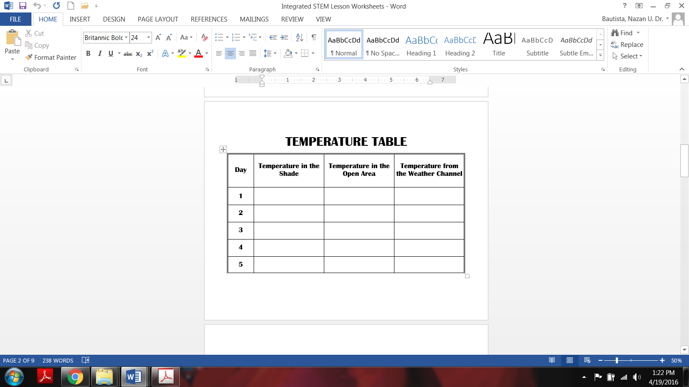

Once enough data is gathered for students to see the pattern, teacher can bring students together to discuss the data. Each group or student should be encouraged to share what they can tell about which location the best is, based on the data gathered. It is important to remember that here we are not asking students how the temperature value has changed throughout the day. They are only comparing the temperature values with the data gathered from the Weather Channel.

Students do similar investigations for the rain gauge by placing a rain gauge at a location that is clear of any trees or a building and placing another identical rain gauge at a location near the school building or a tree. This investigation may need more days depending of the times of the year, if rain or snow is not likely. This investigation only requires students to check the water or snow level in the rain gauge on a daily basis and compare the values.

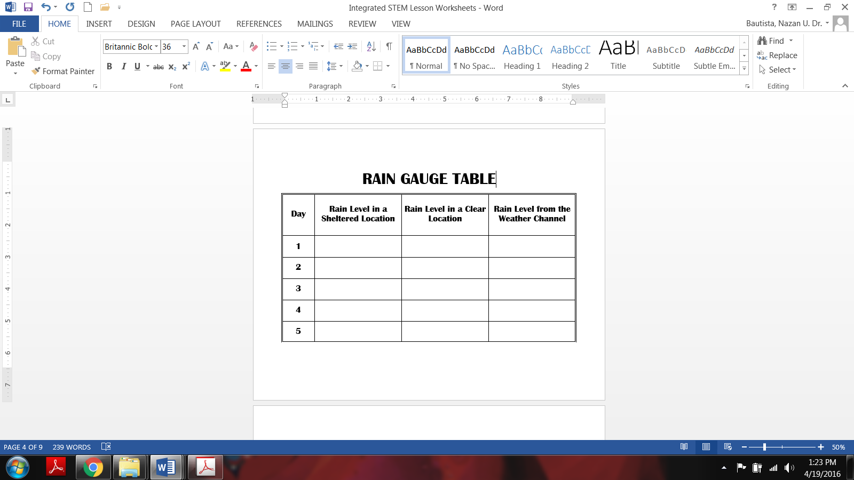

Anemometer and wind sock can be investigated together. Students place one set in an open area and another set at a location (e.g., near a wall) that blocks the wind. Students can make immediate observations with the anemometers and wind socks at these two locations to determine if they behave differently based on where they are placed.

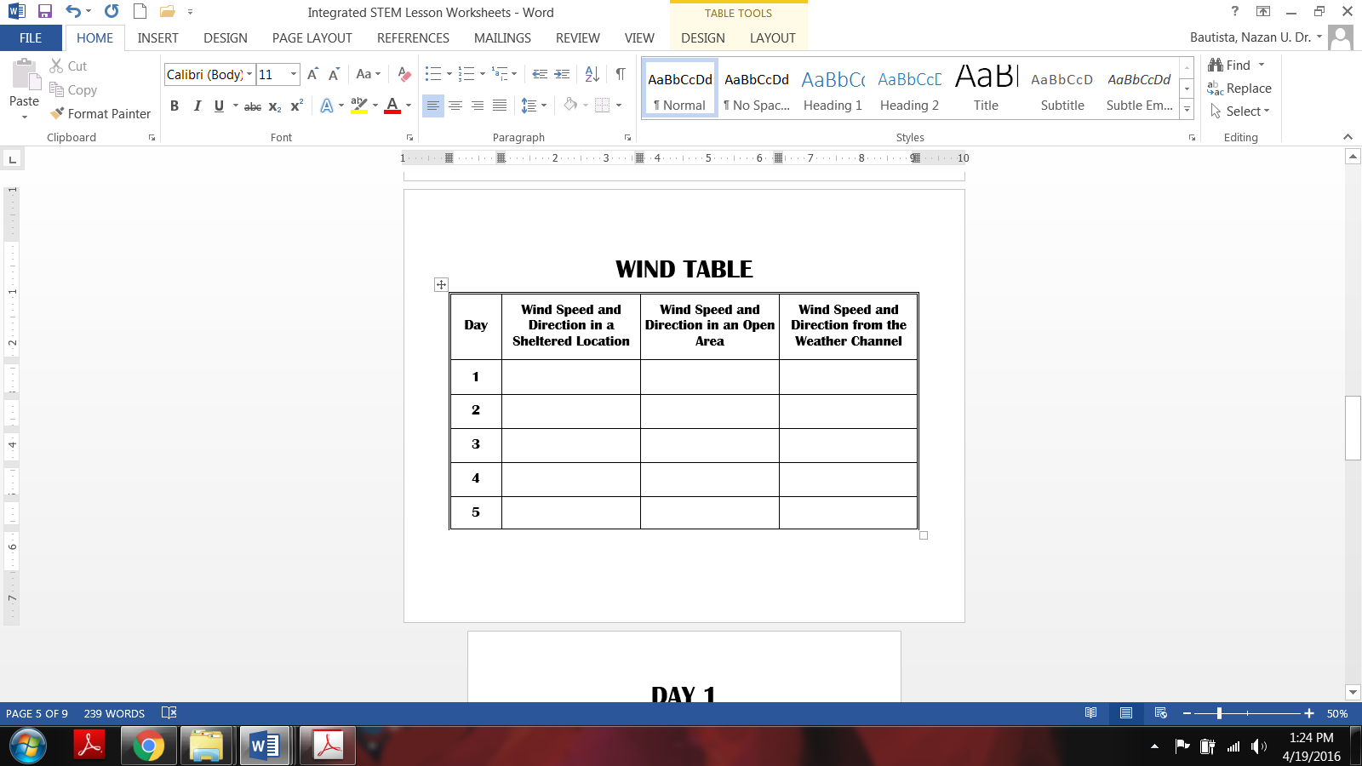

After the investigations are done, ask students to share what they concluded based on their data and observations. Then, teacher addresses the best location for each weather instrument.

Resource for teachers: <https://climate.ncsu.edu/edu/k12/.instruments>

**Lesson 3:** **Using weather instruments to investigate short-term & long term weather.**

Background: This lesson will include a multiple sets of lessons/activities in order for students to fully understand the short and long-term weather changes. Students will be investigating short-term weather changes through a 2-week long inquiry activity at the beginning of the year (preferably in August) and will repeat the same 2-week long investigation 3 more times in fall (e.g., October or November), winter (February) and spring (April or May). The 2-week long inquiry will help students see the temperature patterns and weather patterns during a short time period (e.g., over the course of a day and over the course of a week) whereas the repetition of the 2-week inquiry activity will help students see the weather patterns throughout the year and how weather events (e.g., type of precipitation and temperature) may be different during different times of the year.

Teacher should purposefully select the 2-week times that s/he will conduct the activities so that the weather patterns students observe represent the different seasonal patterns of their region. For instance, when the weather patterns are similar (e.g., it is expected to snow in winter or experience foliage in fall) teachers in New England area may do the 2-week activity in early October whereas those who are in mid-west (Ohio, Illinois, Indiana) may prefer to do it in mid-November to show the seasonal weather patterns for fall. Those who live in regions where the seasonal weather patterns are different from the other stereotypical weather patterns (e.g., it doesn’t snow in winter and hot and humid with high levels of rain throughout the year OR cold and dry throughout the year with constant presence of snow on top of the mountains), teachers must select the time period that best represents the season of that particular region.

Materials: Weather logs, weather instruments, wall chart for daily weather data, chart paper for discussion notes, compasses.

Teacher Preparation: Prepare a weather calendar for a time period for which the students will be collecting data. Teacher can construct a calendar facsimile with e large (at least 6”x6”) block for each day of the collection week on a large piece of oak tag.

***Short-Term Weather:***

Objectives:

Students should be able to observe and describe the daily and weekly temperature patterns

Students should be able to observe and describe the daily precipitation and sky coverage patterns.

Students should be able to collect and analyze data and communicate results using multiple visual representations (e.g., charts and tables).

Procedure:

Ask students to share how the weather change daily and repeat the same question later by changing “daily” with “weekly.” The purpose is to get students to think about their daily experiences in relation to weather by thinking more scientifically and make them aware of the daily observations they make about weather and weather events.

Tell students that for the next 2 weeks, they will be investigating various weather variables, including temperature, precipitation, wind speed and wind direction, and sky coverage. Using the knowledge they gained from the previous activity (best location for weather instruments), collectively with students find a location that will provide the best weather data and securely place these instruments at this location.

Students are expected to gather data in the morning (when they arrive at school), at noon (before lunch) and in the afternoon (before the school is over). Students will have a weather journal in which each page will have a log for students to record their data and observations.

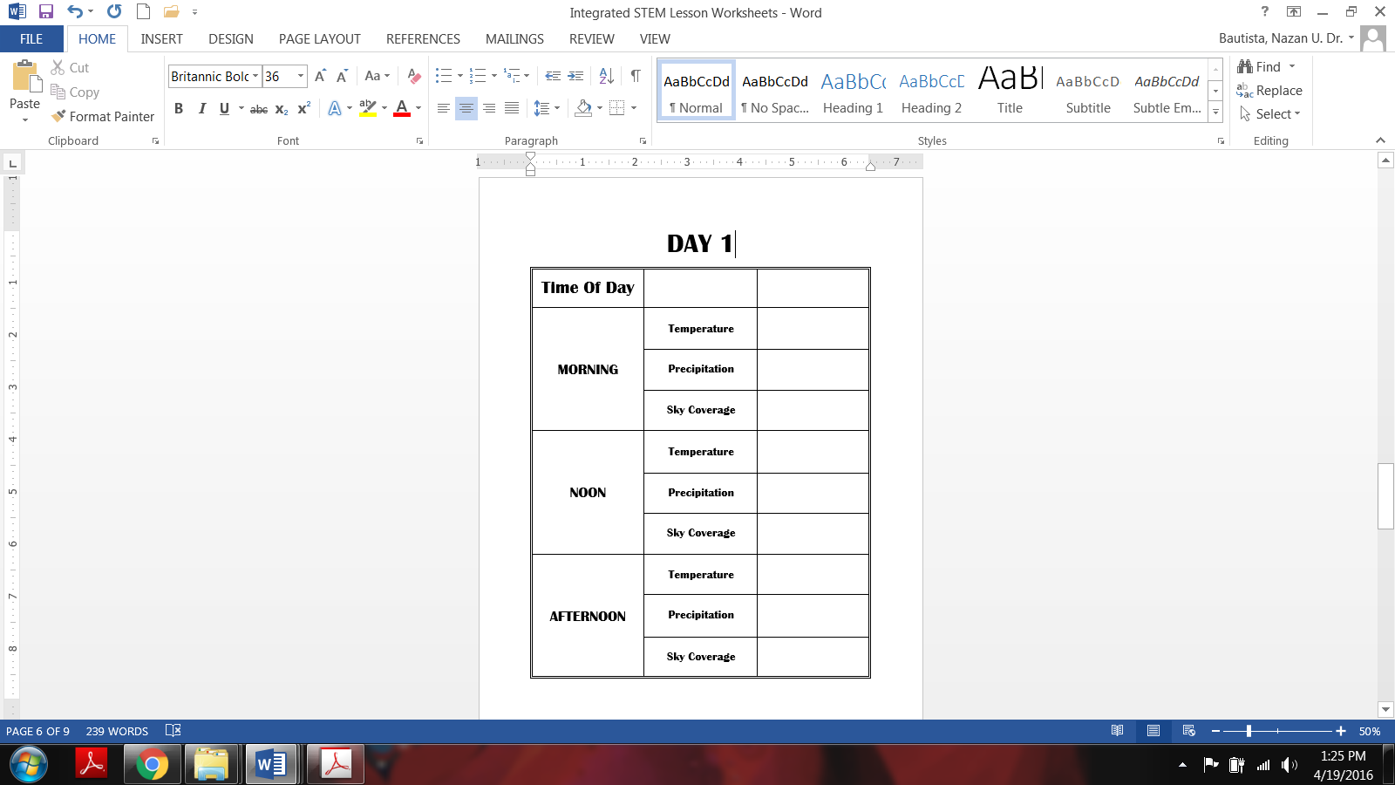

**After each data collection, students come back to the classroom and transfer their data on the 2-week long weather chart which helps students view all collected data together, which will help them see the patterns and develop explanations about weather patterns throughout the instruction.**

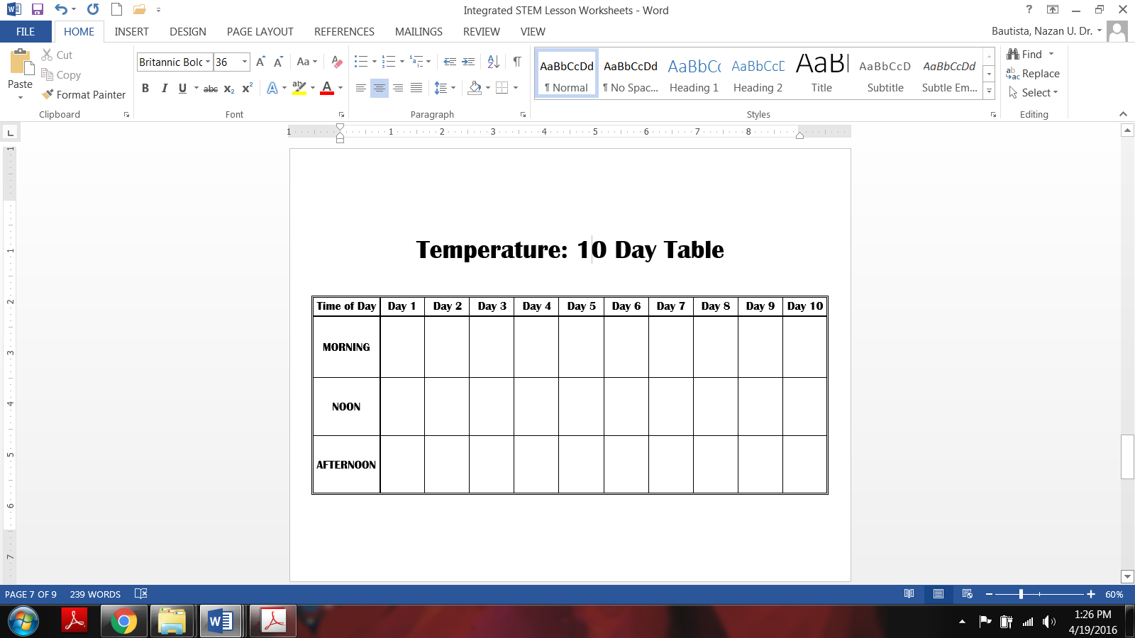

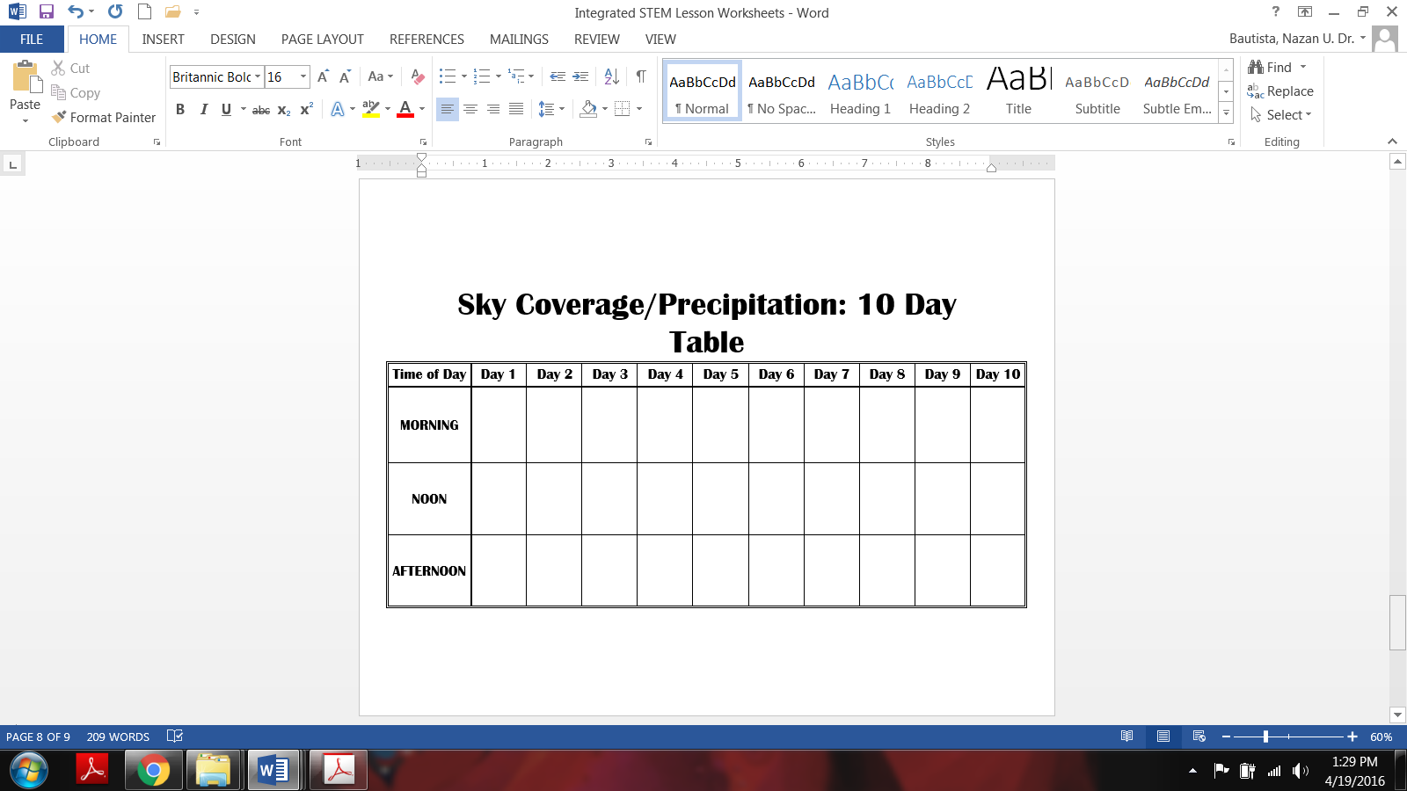

After two weeks of collecting weather data, teacher gives students some independent time to look at the weather logs and the chart in their small groups. Ask students to pay attention to the patterns and trends they see. Then, bring everyone for the whole class discussion. Ask questions such as “How did the weather change during the week?” “How would you describe the weather for the two week period? Does the temperature seem to be going up, down, or staying the same? Was there any relationship between the wind and the temperature the next day? Was it colder on cloudy days? Was it colder on days that the wind was coming from the north and warmer when the wind was coming from the south?”

Mathematics:

To improve students’ computational skills, use the collected data to have them create various weather variable graphs. At the end of the 1st week, teacher uses the sky coverage data to teach about bar graphs. Each student receives a picture representing the sky coverage data collected that week. Teacher sorts students based on the sky coverage picture they are holding (e.g., all cloudy days, all sunny days, all rainy days, all snowy days, etc. are grouped together). Then teacher lines students up to create a human bar graph. Asks students to share one thing about the graph they built (e.g., there are more sunny days than rainy days). After this students are directed to put the pictures on an already labeled packet chart to create a pictogram. Teachers ask students to share one thing about the story the pictogram tells. Teacher explicitly addresses that the human graph and the pictogram present the same information, that scientists or STEM people use visuals such as tables and graphs, pictograms, etc. to present their research findings/ data. (Science & Math connection)

Group 1: Morning temperature vs. Day line graph

Group 2: Noon temperature vs. Day line graph

Group 3: Afternoon temperature vs. Day line graph

Group 4: Temperature vs. time of the day bar graph

Group 5: Number of days vs. type of precipitation/sky coverage

Based on the graphs Groups 1, 2, and 3 draws, students can answer questions such as “what was the coldest and warmest days?” “what was the difference between the coldest and warmest day?”

Based on the graph Group 4 draws, students can answer “how does the temperature change over the course of a day?” “How is the daily temperature change similar or different throughout the investigation?” For the graph by Group 5, students can explain number of rainy, cloudy, snowy, etc. days.

Crosscutting Concepts: Teacher uses temperature information to address the **patterns**. Students will label the temperatures as cool, cooler, coolest or warm, warmer, hot (depending on the season).

**Technology: Is the information collected with tools they made same or similar to the data collected and reported by scientists?** Students gather weather data from internet and create graphs and compare these graphs with the ones they made using the data collected with the developed instruments. Teacher explicitly asks questions and facilitate conversations about the role of technology in the advancement of society.

***Long-Term Weather***

Objectives:

Students should be able to describe the seasonal temperature patterns

Students should be able to describe the seasonal precipitation and sky coverage patterns.

Students should be able to analyze data and communicate results using multiple visual representations (e.g., charts and tables).

Procedure:

Students repeat the “short-term weather” investigation (explained above) throughout the year; in fall, winter, and spring. At the end of each month, teacher asks students to review the data, make graphs using the data and discuss the characteristics of weather for that particular month (patterns). Students make claims, provide evidences and explain their reasoning. We recommend that teacher assigns each group to create different graphs every time the activity is completed (e.g., Group 1 does “morning temperature vs. time(day)” graph the first time and then does “noon temperature vs. time(day)” graph the next time).

At the end of the school year, teacher presents all weather charts, temperature and sky coverage/precipitation graphs in a meaningfully organized manner so that students can see the changes, if any, in patterns (e.g., all morning temperature vs. time graphs side by side). Teacher should have ample amount of time for students to review, discuss, and infer based on the data and the graphs. Teacher should guide students with questions to ensure that students recognize;

* Temperature can vary during the day (e.g., cooler in the morning, warmer at noon, and cooler in late afternoon etc.) They will be able to see these patterns both during short-term and long-term weather investigations.
* Precipitation and sky coverage can vary during a day, over a week, and over a year.
* There is a relationship between temperature, wind and sky coverage/precipitation patterns.
* There is a seasonal temperature and sky coverage/precipitation pattern.

|  |  |  |
| --- | --- | --- |
| FIRST NUMBER | **<**  OR **>** | SECOND NUMBER |
| 1 | **<** | 5 |
| 4 |  | 3 |
| 7 |  | 5 |
| 6 |  | 9 |
| 17 |  | 21 |
| 53 |  | 36 |
| 78 |  | 91 |
| 65 |  | 43 |
| 75 |  | 57 |
| 48 |  | 69 |

LESS THAN OR GREATER THAN?

|  |  |  |  |
| --- | --- | --- | --- |
|  | Cup 1 | Cup 2 | Cup 3 |
| Temperature of Water |  |  |  |

TEMPERATURE OF WATER IN CUPS

TEMPERATURE TABLE

|  |  |  |  |
| --- | --- | --- | --- |
| Day | Temperature in the Shade | Temperature in the Open Area | Temperature from the Weather Channel |
| 1 |  |  |  |
| 2 |  |  |  |
| 3 |  |  |  |
| 4 |  |  |  |
| 5 |  |  |  |

RAIN GAUGE TABLE

|  |  |  |  |
| --- | --- | --- | --- |
| Day | Rain Level in a Sheltered Location | Rain Level in a Clear Location | Rain Level from the Weather Channel |
| 1 |  |  |  |
| 2 |  |  |  |
| 3 |  |  |  |
| 4 |  |  |  |
| 5 |  |  |  |

WIND TABLE

|  |  |  |  |
| --- | --- | --- | --- |
| Day | Wind Speed and Direction in a Sheltered Location | Wind Speed and Direction in an Open Area | Wind Speed and Direction from the Weather Channel |
| 1 |  |  |  |
| 2 |  |  |  |
| 3 |  |  |  |
| 4 |  |  |  |
| 5 |  |  |  |

DAY 1

|  |  |  |
| --- | --- | --- |
| Time Of Day |  |  |
| MORNING | Temperature |  |
| Precipitation |  |
| Sky Coverage |  |
| NOON | Temperature |  |
| Precipitation |  |
| Sky Coverage |  |
| AFTERNOON | Temperature |  |
| Precipitation |  |
| Sky Coverage |  |

|  |  |  |  |  |  |  |  |  |  |  |
| --- | --- | --- | --- | --- | --- | --- | --- | --- | --- | --- |
| Time of Day | Day 1 | Day 2 | Day 3 | Day 4 | Day 5 | Day 6 | Day 7 | Day 8 | Day 9 | Day 10 |
| MORNING |  |  |  |  |  |  |  |  |  |  |
| NOON |  |  |  |  |  |  |  |  |  |  |
| AFTERNOON |  |  |  |  |  |  |  |  |  |  |

Temperature: 10 Day Table

Sky Coverage/Precipitation: 10 Day Table

|  |  |  |  |  |  |  |  |  |  |  |
| --- | --- | --- | --- | --- | --- | --- | --- | --- | --- | --- |
| Time of Day | Day 1 | Day 2 | Day 3 | Day 4 | Day 5 | Day 6 | Day 7 | Day 8 | Day 9 | Day 10 |
| MORNING |  |  |  |  |  |  |  |  |  |  |
| NOON |  |  |  |  |  |  |  |  |  |  |
| AFTERNOON |  |  |  |  |  |  |  |  |  |  |