**Appendix 1: Developing Socioscientific Case Studies**

A case study is a learning experience in which science students explore an issue or problem with two or more possible resolutions, any one of which may be satisfactory to many members of society while at the same time affecting all of society.

Case studies offer a valuable tool for diversifying the ways that science is taught. Students find that cases are an interesting way to examine contemporary issues, and instructors find them helpful for accomplishing several learning skills at once. Best of all, they are exciting to teach because they transform the classroom into an engaging and provocative context.

Cognitive processes used by students in resolving a case study include:

1. Scientific inquiry
2. Technology design
3. Decision-making

**Case Studies Assignment[1]**

This assignment involves a team of 4 teacher candidates working together to develop and conduct a case study based on a socio-scientific (SSI) issue. Hence, you will be assuming two roles; that of a teacher and a student. The case study ideally will be aligned with the Application expectations of the Ministry of Education Ontario Curriculum: Science, Grades 9-10. Groups will present their case studies on the final day of class.

1. Choose a **socioscientific issue** in science education (from the literature or elsewhere). You are required to link it to a topic in the Ontario Science curriculum (Grades 9-10), and align the case study content with the chosen topic and curriculum expectations.
2. Develop a series of **lesson plans** (maximum 3) around the case study, including activities and assessments. This will also include a lesson for conducting the case study (i.e., debate, Town Hall meeting, etc.)
3. Develop a **scenario** for introducing the topic. It should be clearly defined, provide background information to enable students to complete the task/answer the questions, or engage them in research to obtain the information required.
4. **Addressing** the socioscientific issue will require the following steps:
5. Identifying the issue
6. Identifying the stakeholders in the issue
7. Researching the issue (understanding the scenario and going further)
8. Identifying the perspective(s) of each stakeholder
9. Identifying potential consequences
10. Identifying the alternatives
11. Identifying the kinds of research that need to take place to help resolve the issue or reach the best alternative
12. Taking a stand

In addressing the socioscientific issue, you will be required to complete a number of activities that comprise the research and development of the case study. Your group will be responsible for completing and submitting the following as part of the case study package:

1. **KWL Graphic Organizer (one per stakeholder)**
2. **Cornell© Note-Taking Framework (one per stakeholder)**
3. **Consequence Map (one per stakeholder AND one illustrating ALL stakeholders’ perspectives)**
4. **Cost-Benefit Analysis (one per case study)**
5. **KWL Graphic Organizer**

Topic:

|  |  |  |
| --- | --- | --- |
| **What I know** | **What I want to know** | **What I learned** |
| 1.  2.  3.  4.  5.  6.  7.  8. | 1.  2.  3.  4.  5.  6.  7.  8. | 1.  2.  3.  4.  5.  6.  7.  8. |

1. **Cornell© Note-Taking Framework**

Topic:

Source:

|  |  |
| --- | --- |
| **What I Want to Know** | **From Research** |
|  |  |

**Short Summary of Notes (Analysis):**

1. **Consequence Map**

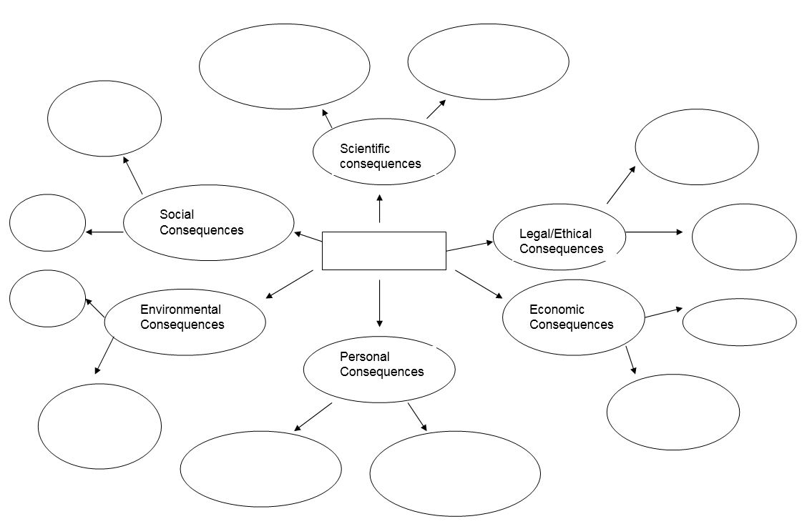

The following are a sample of questions that are applicable to various stakeholders’ perspectives. You may incorporate some of these or develop your own as you create your consequence map.

**Scientific Consequences**

* Will the issue promote basic scientific research?
* What is the fundamental science upon which this issue is based?

**Ethical/Legal Consequences**

* What individual rights might be violated?
* How does it promote the common good?
* What are the related ethical issues?

**Environmental Consequences**

* How does it affect our environment in the short term?
* How does it affect our environment in the long term?

**Social Consequences**

* How are different groups of people affected?
* What portions of society does it bring together, and what portions does it divide?
* What effects will it have on lifestyle and living conditions?

**Personal Consequences**

* How does it affect you in the short term?
* How does it affect you in the long term?

1. **Cost-Benefit Analysis Model[2]**

Cost-benefit analysis is a tool used to critically assess the research that you conducted in order to develop the case study. A thorough and critical analysis of the costs and benefits associated with each alternative solution can guide your decision on the best alternative.

In order to conduct an effective cost-benefit analysis, you must complete the following steps:

* Classify each potential result as being either a benefit or a cost.
* Quantify the size of the potential benefit or cost (e.g., monetary, lives affected, or on a scale of 1 to 5).
* Estimate the probability (percentage) of that event occurring.
* By multiplying the size of a benefit (or cost) by the probability of the occurrence, you can calculate a probability value for each potential result.
* Total the probability values of all the potential costs and all the potential benefits.
* Compare the sums to help you decide the feasibility of the proposed action.

|  |  |  |  |  |  |  |  |
| --- | --- | --- | --- | --- | --- | --- | --- |
| **Possible Result** | **Costs** | | | **Possible Result** | **Benefits** | | |
| Cost of Result | Probability of result occurring (%) | (Cost) x (probability) | Benefit of result | Probability of result occurring (%) | (Benefit) x (probability) |
|  |  |  |  |  |  |  |  |
|  |  |  |  |  |  |  |  |
|  |  |  |  |  |  |  |  |
| **Total**  **Cost Value** |  |  |  | **Total Benefit Value** |  |  |  |

1. **Case Study Presentation**

Case study presentations can take the following forms, in addition to other formats:

1. **Role Playing:** Role-playing involves assuming someone else’s role in order to better understand his/her point of view. The scenario has to present the opportunity for at least 3 important roles. For example, with the issue “Are high-voltage power lines a threat to health”, roles might be a farmer who claims that cattle grazing near power lines are in danger of exposure to electro-magnetic fields; a gynecologist serving patients in a community near power lines; a power company engineer; a scientist involved in researching the issue.
2. **Position Paper:** A position paper argues and persuades using facts, anecdotes, and descriptions to convince the reader of the truth of a thesis. Any topic for which more than one answer is possible is suitable for a thesis. An inductive position paper discusses the merits of counter-arguments before presenting the argument for the thesis. The writer then anticipates the reader’s objections. A deductive position paper often begins by clearly stating the point of view of the writer and the thesis for the argument. For example, “building more bike paths would reduce air pollution in major cities”. The argument should appeal to the reader’s intellect through reason and logic. Facts and evidence are usually presented to support the thesis.

**Submission Checklist**

Lesson Plans (maximum of 3)

Case Study package including:

Learning Goals

Case Study Scenario

List of Stakeholders

KWL Graphic Organizer for each stakeholder

Cornell© Framework for each stakeholder

Consequence map for each stakeholder

Consequence map representing all stakeholders’ viewpoints

Cost-Benefit Analysis

Presentation/Assessment of the case study

1. This assignment was developed by Isha DeCoito and has been taught over the years and researched in her science methods and science, technology, engineering and mathematics (STEM) focused courses.
2. The cost-benefit analysis was adapted from *Nelson Science & Technology Perspectives 7* © 2009, Nelson Education Ltd.