APPENDIX A

**Build a Child Cardboard Challenge**

**The Challenge**

Your challenge is to build a person using cardboards, representing a living school-age child.

**Design Principles**

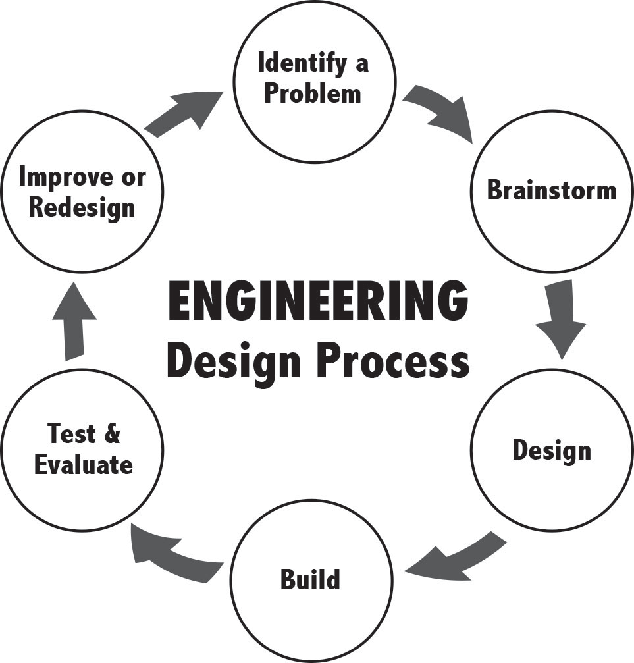

The steps engineers take to arrive at a solution are called the ***engineering design process***.

As you work through your cardboard challenge, use the guiding principles provided on the right.

Please note that you have limited number of supplies. It is important that, you decide the most effective ways to use these supplies and resources to create the cardboard child. Therefore, it is important that you carefully ***examine*** every item you have and ***plan*** which items will be used and how they will be used for the challenge you ***design*** prior to ***building*** your cardboard child.

**Rules & Guidelines**

* You are only allowed to use the cardboards and the Makedo tools provided.
* The cardboard child you design can be 2-D or 3-D and should be between 40” and 50” tall.
* The product should have at least 4 moving parts.
* Each of you will build your own cardboard child; however, you can assist each other (e.g., brainstorm together or provide suggestions for improvement) as you move through engineering design principles.
* Once your cardboard child is ready, ask the teacher to check your design.

**Write the Child’s Story**

In this part of the lesson, the cardboard child will come alive. You will write your child’s story as detailed as you can. You cannot share information with your peers during this process. Once you are done, have the teacher check your essay and confirm that it is ready for you to share with the class through an oral presentation.

Below is the list of questions to guide you in writing. However, you are not limited by these questions:

Describe the child and write its story.

* What is the child’s gender, race, ethnicity, etc.?
* Describe the child’s personality, likes and dislikes, hobbies, etc.
* Describe the child’s family and social environment.
* Where does the child live? Describe the environment.
* What is the child good at and what is difficult for “it?”
* What is the child looking forward to this year?
* What are the child’s goals this year?
* How is the child’s academic performance?
* What is the child’s favorite and least favorite subjects?

Critical Examination of the Designs & Stories

In this section, you will examine the children you designed and their stories with a critical lens.

Imagine that the children you built and narrated are the children in your future classroom. In small groups, discuss the composition of your classroom. The main questions to answer,

* Who are/aren’t represented in your classroom? [Alternatively: Who did we neglect?]
* Whose voice is likely to be heard? Whose voice is likely to be lost? [Alternatively: Whose voice is dominant? Whose voice is dominated?]
* How similar the composition of the cardboard student classroom to the composition of our classroom?
* What does this activity say about who we see and find important and who we will we recognize as our target audience in classroom? [Alternatively: What assumptions or biases exist about our future students?]
* How do you plan to build relationships with students who are culturally different than yourself?
* After this experience, what are some major takeaways in regards to what it means to be a socially-just science teacher?

Some variables to consider:

* Gender representation?
* Race & ethnicity representation?
* Sexual orientation representation?
* Religious affiliations?
* Socio economic status / poverty
* Access to resources