Appendix A: The Extra Piece Activity
In Choi’s (2004) activity, after cutting all pieces from Figure A1a, all the pieces except the small square marked X are handed out to the students. Students will arrange the pieces, and they will likely reach the conclusion found in Figure A1b. In this stage, the small square marked X would be given to the students as a new discovery in science, and they should try to fit it into their puzzle. The following NOS elements would be discussed then with students (We should emphasize we just quote this activity’s elements although we are not in agreement with the way some of them are written):
1) Assume that the pieces fit together—nature is a puzzle that we have not yet solved; 2) Trial and error is an essential ingredient to science; 3) New information may require the old theory to be modified or discarded; 4) Our current information may be incomplete and therefore, our theories incorrect; 5) Sometimes, we get lucky and find the right answer; 6) Collaboration may be helpful; and 7) Once we arrive at the answer, it makes a perfect, elegant sense. (Choi, 2004)
Figure A1
Patterns of Choi’s Activity
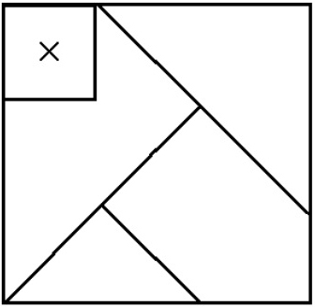 | 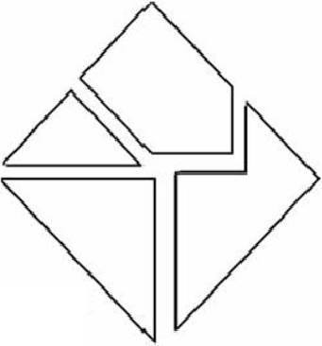
(a) | (b)

Appendix B: Worksheet for the Tangram Activity
Worksheet for the tangram activity
Group members: | Group Number:
Assumptions:

Introduce all pieces that you want to use for solving your puzzle.

Groups 1 and 2, please draw the final shape(s) of your puzzle.

Group 3, please draw all possible arrangements here and predict the shape and color of a piece you need to complete your puzzle if you are not able to complete it with the pieces you already have.

Introduce your new piece and consider if the new piece meets your assumptions:

What do you want to do with your new piece?

Groups 1 and 2, please draw all possible arrangements here and predict the shape and color of a piece you need to complete your puzzle if you are not able to complete it with the pieces you already have.

Group 3, please draw the final shape of your puzzle.

All groups should draw their final puzzles on the board and announce their probable prediction(s) about the piece(s) that they need and their extra piece(s).

