Appendix A
In-Person CTSI Workshops

Activity | Detailed description
Day 1
Prior to CTSI | Teachers received information about CTSI structure and information on parking and meeting spaces.
Doors open  (30 minutes before the start of CTSI) | Doors opened at 9:30 a.m. with a continental breakfast. Participants mingled and chatted informally. Teachers received a folder with CTSI handouts, paperwork, and CT-STEM swag (see Table 2).
CTSI Pre-CTSI survey  (20 minutes) | Teachers completed a pre-CTSI survey about their perceptions and knowledge of CT. Teachers and researchers responded to a short quiz on random topics (e.g., favorite food) for the next activity.
Introductions and Icebreaker  (30 minutes) | Teachers and researchers introduced themselves to the group and engaged in an icebreaker activity. Participants paired up and scanned a computational device to display answers for which participants had common ground on the quiz (e.g., “tacos”). Two researchers then showed how the device could not only start conversations but also collect metadata on who paired up to identify social networks.
Introduction to CT-STEM and CTSI  (10 minutes) | A researcher gave a short presentation about the history and motivation of the CT-STEM project, including research goals, learning objectives, and the focus on collaborating with teachers.
Goal setting  (50 minutes) | Participants used Post-its to brainstorm their own goals for CTSI and their goals for teaching students CT in their classrooms (see Figure A1 and A2). Teachers used green Post-its, and researchers used blue Post-its. In a whole-group discussion, all participants shared their goals and identified common themes across Post-its as a group (see Figure A2). These goals were displayed in the common meeting space throughout the 4 weeks and were reviewed in Week 3.  Figure A1  Teachers and Researchers Discuss and Organize Their Goals Thematically  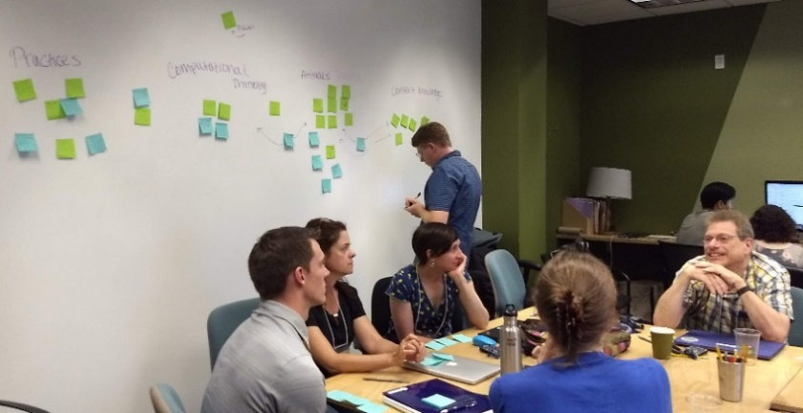  Figure A2  Goals Were Collected and Displayed on the Wall Throughout CTSI  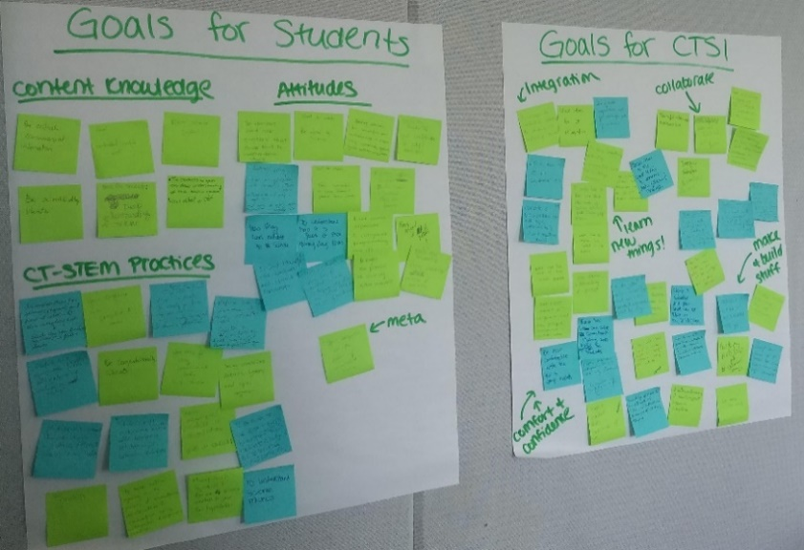
Catered Lunch
Teacher Demo of CT-STEM lessons  (70 minutes) | All teachers and researchers participated as “learners” to understand how students can engage in CT to learn STEM content.  One biology teacher engaged the rest of the group in a paper-and-pencil activity on genetics (25 minutes) typically taught in her class. The teacher first described the goals of the activity and asked learners to hold a set of dominant and recessive alleles written on paper and then “mate” with a partner. Partners drew from the handheld sets of paper, resulting in offspring with a randomized set of alleles. After cycles of mating spawned five generations of offspring, the group discussed alleles, phenotypes, and other related concepts.  Then, the teacher engaged learners in two codesigned CT-STEM lessons about genetics (35 minutes) that were codesigned by the biology teacher and a researcher in the last school year to replace the paper-and-pencil activity (https://ct-stem.  northwestern.edu/curriculum/preview/681/). In the first lesson, participants observed changes in the population of mice over time in a computational model of rock pocket mice, based on a phenomenon highlighted in a Howard Hughes Medical Institute Biointeractive (https://www.hhmi.org/biointeractive/pocket-mouse-evolution). Participants used the model to explain how the color of fur changed because of a change in the environment where mice lived. In the second lesson, participants used an advanced version of the model that shows phenotype frequencies to understand the Hardy-Weinberg equilibrium mathematically and computationally.  To engage in this activity, all participants created student accounts on the project website and were enrolled in the lead teachers’ class.
Panel  (50 minutes) | A facilitator engaged the lead teacher and researcher in a panel discussion on their codesign experience, the experiences of students in the teacher’s classroom, and how the teacher’s role changed in the classroom when implementing the CT-STEM unit. Note that because there was no summer institute the previous year, the teacher and researcher met regularly throughout the year to codesign the unit.  See Peel et al. (2020) for a more detailed discussion of this teacher’s experiences and perceptions of her experience.
Day 2
Introduction to Computational Models  (120 minutes) | Participants logged into the project website using the student account created on Day 1 and engaged in workshops as learners.  A researcher led the group in an Intro to Learning With Computational Models lesson (https://ct-stem.northwestern.edu/  curriculum/preview/495/) that engages students and teachers in various CT-STEM practices and tools (60 minutes). The lesson first asked participants to use, modify, and debug a series of computational models that simulate how fire spreads through a forest using NetLogo (http://tinyurl.com/netlogofire). Next, “students” collected and analyzed “density vs. percent burned” data using CODAP. Then, they posed research questions about other variables that an affect the spread of fire and discussed how scientists use such computational models in their work.  Finally, participants reflected on the pedagogy used by the researchers to engage learners in CT-STEM practices (40 minutes). They discussed how the researcher first demonstrated how to use NetLogo and CODAP before learners engaged with them in pairs and then brought the group together for whole-class discussion after each tool. They also discussed how he managed class time, leveraged responses from the learners, and encouraged discussions between partners to ensure students stayed on task.  The teachers then discussed their initial ideas for using computational models or data analysis tools with their students (15 minutes).
Catered Lunch
CT-STEM Student Learning Analysis  (60 minutes) | A researcher engaged participants in reviewing and analyzing clips of classroom video data of students engaging in CT-STEM lessons. Two clips focused on a chemistry lesson that used video and a computational model to teach particle movement (further described in Day 3 below), and one clip focused on how the participants used CODAP to analyze patterns in the relationship between density and spread of fire that morning. For each clip, the participants analyzed what science content and practices students could have learned, as evidenced in the video.
CT-STEM Pedagogy  (60 minutes) | The participants were split into small groups to discuss CT-STEM pedagogical practices and analytics that can more effectively help their students engage in CT (see Figure A3). Participants wrote ideas for implementation and design on flipchart paper. Each group then shared their ideas with the whole group. These ideas were displayed in the common meeting space throughout the 4 weeks and were reviewed in Week 4.  Figure A3  Participant Groups Brainstorming Ideas for Design and Implementation of CT-STEM Units  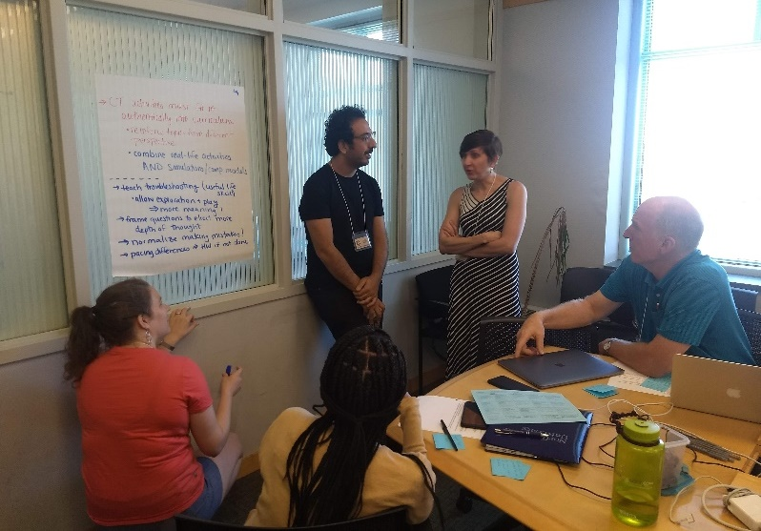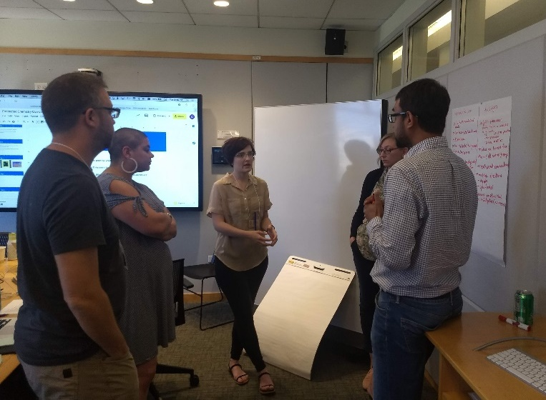  Note. After small-group brainstorming sessions, ideas were collected on sticky chart paper and posted on the wall for the entirety of CTSI.
Computational Tools: Unplugged  (60 minutes) | Participants logged on as students. A researcher engaged participants in a chemistry unit on molecular particle collisions that used several tools to foster CT (https://ct-stem.northwestern.edu/curriculum/preview/565/). First, “students” engaged in an Unplugged activity, which aimed to teach CT without computational tools. The participants watched a video about an air duster that works after being pumped with air and then drew how they think the air duster is able to spray using paper and pen. Then, they broke up into small groups to write pseudocode, or a sequence of steps that a computational model can take, to simulate the movement of the particles. The small groups reviewed and tested a few other groups’ pseudocodes. In a whole-group discussion, they reflected on the activity, and identified how students could use computational principles (e.g., branching or looping) to build computational models.
Computational Tools: NetTango  (60 minutes) | Participants then used NetTango, a blocks-based programming interface for building and exploring NetLogo Web models, to simulate the behavior of two particles in a box. Initially, the particles were set to move “zig-zag,” and if they touch the wall, they bounce back “like a football” in the starter model (https://anttango.netlify.app/tango/gpc.html). Participants worked in pairs to edit blocks and change the parameters of the blocks so that particles moved as realistically as possible.  Each pair then tested their edited block-based code in a model with hundreds of particles in a box (https://ct-stem.  northwestern.edu/curriculum/preview/513/page/7/). In the model, they drew an air duster, put in particles, and observed what happened when the duster sprays.  After each task, participants discussed what they learned from using these models and how they can use NetTango programming and models in their own curriculum. One chemistry teacher used this unit in her class in the last year and shared her experiences teaching with these models.
Catered Lunch
Computational Tools: NetLogo  (90 minutes) | In the afternoon, participants continued learning about particles in chemistry using NetLogo and CODAP. First, participants used a NetLogo model to simulate an experiment. They ran three trials that varied the number of particles and observed the resulting pressure. They recorded results in a data table and sketched a hypothesized trend in a graph.  Next, to show the value of CODAP as a computational data analysis tool, participants repeated the experiments in CODAP, which automatically recorded the results of each trial. They used the CODAP graphing tool to plot the number of particles vs. pressure and observe the trend.  Participants then used the tools to run additional experiments that illustrate the importance of sample size and used their data to derive a mathematical equation for particles vs. pressure. All participants then reflected on how computational tools can engage students in experimental design and statistical analysis.
Computational Tools: Discussion  (30 minutes) | Finally, the participants discussed what they learned this day as well as questions and concerns they had about using various computational tools in their classroom. They also discussed how the sequence of unplugged, NetTango, NetLogo, and CODAP activities can be useful in their own contexts.
Day 4
Introduction to Programming: Unplugged  (60 minutes) | A researcher engaged participants in exercises to help them learn how to program. Participants were randomly placed into small groups. Each group was asked to create a life-sized grid with start and end markers using masking tape on the floor to represent “patches” that people can stand on (see Figure A4). Participants rotated between roles as a “turtle” who follows a small set of programming instructions (i.e., forward 1, right 90 degrees), a “programmer” who directs the turtle, and “obstacles” that stand between the start and end markers. At each round, the researcher removed or added options to the set of instructions to introduce programming concepts such as loops.  Figure A4  Two Teams Participate in the Turtle Programming Exercise  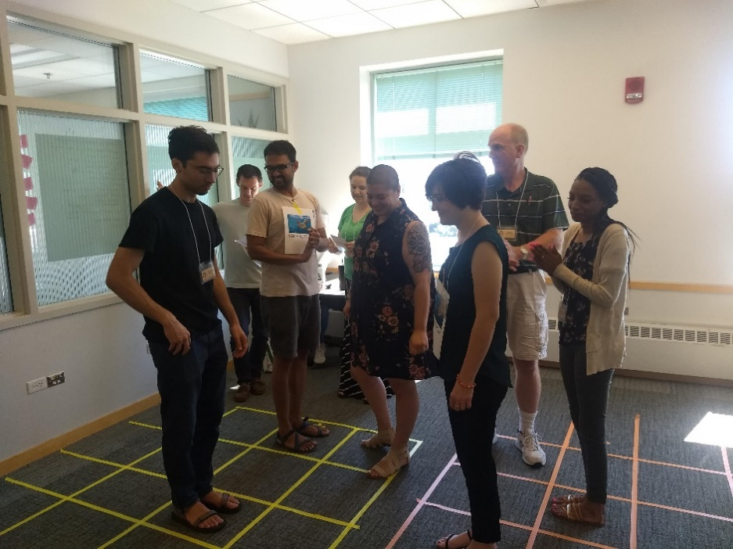  Note. Participants in two teams each use a set of programming instructions to move a “turtle” around “obstacles” in “patches” created by a grid of colored masking tape.
Introduction to Programming: NetLogo  (60 minutes) | Then, participants shifted to their individual computers to program instructions in the digital NetLogo environment and complete increasingly complex programming tasks (e.g., create a pattern and draw an any-sided polygon).
Catered Lunch
Intro to Codesign | A researcher provided an overview of the handouts (see Table 2) and discussed the shift to codesign sessions over the next 3 weeks.
Codesign meeting | Participants gathered in codesign teams to discuss possible curricular topics and learning objectives for their computationally enriched curriculum. Each team shared ideas and formed a plan for what they would individually accomplish while working from home on Friday and Monday.
Reflection | All participants engaged in a whole-group discussion about the week and completed a reflection survey.

Appendix B
Online CTSI Activities

Activity | Detailed description
CTSI Prework | Teachers completed a survey about their familiarity with and obstacles to using specific technology. After researchers reviewed the survey, teachers were asked to set up Zoom, join a team Slack, and join CTSI Google Classroom as students.  Then, teachers received information about CTSI structure and an intro to the graduate and undergraduate researchers on the CTSI support team. They were also asked to complete a pre-CTSI survey about their perceptions and knowledge of CT.
Day 1
Welcome  (30 minutes before the start of CTSI) | Zoom session was open at 9:30 a.m.
Icebreaker  (30 minutes) | Teachers and researchers first engaged in an icebreaker activity (30 minutes) in which participants were sent to breakout rooms to find what they had in common. A reporter introduced their group members and their commonalities and also shared them in the chat feature (e.g., “love plants” and “Batman!”).  A facilitator explained the following asynchronous activities hosted on Google Classroom.
Introduction to  CT-STEM and CTSI/Break  (50 minutes, asynchronous) | Participants watched an 8-minute video presentation about the history and motivation of the CT-STEM project, including research goals, learning objectives, and the focus on collaborating with teachers (https://www.youtube.com/watch?v=stzsbw7yuAs). Participants used virtual Post-its on Padlet to brainstorm their own goals for CTSI and their goals for teaching students CT in their classrooms (https://padlet.com/sally_wu/CTSIGoals). Participants also watched a 7-minute video (https://www.youtube.com/watch?v=H8Y5l_BU4mM) or  reviewed the slides (https://docs.google.com/presentation/d/e/2PACX-1vRhJIuhFNfyFKRR95A-NPNvfB_n9r5_  eAU5v4VbNfyW4f2JH_3zfPpFovRVQJ_SX8FttB7gA-IuPDVh/pub?start=false&loop=false&delayms=3000) about the goals, structure, and resources available for CTSI.
Discussion: CTSI Goals  (30 minutes) | Participants were split into breakout rooms to review their Post-its and identified common themes across goals. Themes and observations were discussed as a whole group. These goals and linkages made between them were available on Padlet (https://padlet.com/sally_wu/CTSIGoals) throughout the 4 weeks.
Lunch Break
(60 minutes)
Introduction to Computational Models  (120 minutes) | All teachers and researchers participated as “learners” to understand how students can engage in CT to learn STEM content.  A researcher led the group in an Intro the Learning With Computational Models lesson that engages students and teachers in various CT-STEM practices and tools (https://ct-stem.northwestern.edu/curriculum/preview/495/). He briefly explained the goals of the lesson and how it has been used by teachers, then helped participants create student accounts on the project website in his class (15 minutes). Participants were assigned to breakout rooms by subject area and worked on one page of the lesson at a time (7 minutes per page).  The first page asked participants to explore the idea of a model, particularly a computational model that simulates how fire spreads through a forest (see http://tinyurl.com/netlogofire) built with NetLogo, a multi-agent programmable modeling environment. The next page asks participants to debug and modify a broken NetLogo fire spread model to understand the underlying code. Then, participants collected and analyzed “density vs. percent burned” data using CODAP, a web-based data analysis environment. Then, they posed research questions about other variables that can affect the spread of fire.  Each page of the lesson included the following prompts at the bottom.  - “List computational activities that students participate in as they go through the questions on this page. Explain how they are expected to participate in those practices.”  - “How would you support student learning through computational activities integrated into this page?”  After working on a page in their breakout rooms, all participants were brought back into the main room to discuss their reactions to each page and their thoughts on how they could teach this lesson (3 minutes per page).  At the end, all participants discussed how the researcher first engaged participants in the lesson, such as how he managed class time, leveraged responses from the participants, encouraged discussions in and out of the breakout rooms, and ensured that everyone stayed on task (30 minutes).
Day 2
CTSI Teacher Panel  (60 minutes) | Three returning teachers who also attended CTSI 2019 were asked to share their experiences from last summer with new teachers. A facilitator engaged the panel in questions about their codesign process, codesigned units, and implementation of these units during the school year. Returning teachers also answered questions from new teachers, such as “what coding did you do for your energy unit,” and “is my understanding correct that some scientific phenomena are too complicated to code with, so we end up using code for basic science concepts?”
Unit Revision or Exploration  (60 minutes) | Returning teachers were sent to breakout rooms with their codesigners to discuss revisions and updates for their units from 2019 to be worked on this week while the new teachers learn about CT-STEM tools.  New teachers were given time to explore other teachers’ units on the project website, including units created by teachers during CTSI 2019. They were asked to create a teacher account on the website, favorite units that they like, and respond to a reflection survey on what they liked about or would improve in the units that they explored. Most teachers left Zoom to work asynchronously, but a few decided to go through units as a group in a breakout room.
Lunch Break
(60 minutes)
CT-STEM Practices and CT-ification  (60 minutes, asynchronous) | Participants reviewed CT-STEM practices using a document (https://docs.google.com/document/d/  1NT_UCM7JJzY5AUq3e39f7rcTe8QLbuGQrCZxUNCMJ_Q/edit?usp=sharing) and slides (https://docs.google.com/  presentation/d/1Ag-b8KDoeNhK26bwSK_rnHJqNRWSMZ9s76W5sg_PGqU/edit?usp=sharing). These resources are meant to be a reference document to aid in understanding the CT-STEM practices and designing CT-integrated science and math units. They describe each CT-STEM practice and give an overview of some of the overlaps between the practices. Curricular examples of the practices were provided with descriptions and links to lessons.  Participants also complete a CT-STEM lesson that helps them identify content that could be “CT-ified” through leveraging computational transparency and scale, as described below (https://ct-stem.northwestern.edu/curriculum/preview/1577/pem_code/BB8PYK387MA5NGSECY33).  - Computational Transparency: “Make computational elements more transparent—take existing technological integration and have students consider, discuss, and learn about the underlying computational power that makes the tool useful.”  - Computational Scale: “Every STEM field deals with problems at scale, whether it be in quantity, size, time, or repeatability, and computational power is increasingly being harnessed to solve those problems.”
CT Practices and Integration Discussion  (30 minutes) | A researcher gave an overview of the CT-STEM practices. Participants discussed questions about CT practices and CT-ification in breakout rooms.
Unit Brainstorm  (30 minutes) | The teachers then met with their researcher partners in breakout rooms to discuss their initial ideas for using computational models or data analysis tools with their students.
Day 3
Introduction to Programming  (75 minutes, asynchronous) | Participants logged on as students and completed a CT-STEM lesson (https://ct-stem.northwestern.edu/  curriculum/preview/1505/) that introduced agent-based programming with activities to help participants learn about commands, properties, parameters, procedures, programs, and conditions through simple simulations and block-based programming.  Instructions: “In the following pages, you’ll be guided through a series of activities meant to introduce you to the basics of programming practice and vocabulary. If you’ve taken a computer science course, much of this may already be familiar to you! Here are some things you shouldn’t worry about while you complete these activities:  - Getting the ‘right’ solution on the first try. What you should do is actively think about how your solutions change as you think about each problem differently.  - Memorizing programming vocabulary. If this is your first time using programming parlance, don’t worry about remembering every particular term. We’ll try to give you a broad overview of how programmers talk about things so that you can talk to your classmates and share your work with your peers.”  The researcher who wrote the lesson was available to answer questions.
Check-In/Discussion  (45 minutes) | This time was originally planned as a workshop on constructionism to help emphasize what students can learn from constructing their own artifacts such as computational models, data, and programs, but the presenter withdrew.  Because teachers had reported feeling overwhelmed with information in workshop feedback and were showing signs of Zoom fatigue, we shifted this time to a check-in. The facilitators shared some of this feedback and offered this time as a break or a chance to discuss issues important to the participants. Participants brainstormed topics that they would want to discuss, voted on what they were interested in, and were sent to breakout rooms to discuss these. Topics included a continued discussion of CT-STEM practices from the day before, a discussion on the programming lesson from the morning, and a discussion of online learning in general. Some participants also chose to take this time as a break or work time for returning teachers revising their units.
Lunch Break
(60 minutes)
Computational Tools: NetTango  (60 minutes, asynchronous) | Participants then used NetTango, a blocks-based programming interface for building and exploring NetLogo Web models, to simulate the movement and behavior of moose and wolves (https://ct-stem.northwestern.edu/  curriculum/preview/353/) in a lesson focused on predator–prey dynamics in ecology.  A researcher was available to answer questions.
Discussion of NetTango  (60 minutes) | Participants went into breakout rooms to discuss their experiences of using the NetTango model and gave insights on lesson planning (50 minutes). Participants then went back to the main room and shared their discussion about student engagement, NetTango interface improvements, pedagogical implications, and other topics (10 minutes).
Day 4
Computational Tools: NetLogo  (60 minutes) | Participants went through a tutorial lesson on NetLogo programming asynchronously. Researchers were available on Slack to answer questions as they came up.
Discussion  (60 minutes) | Participants went into breakout rooms, and researchers walked teachers through how to create simple NetLogo models related to the subjects that teachers teach.
Lunch Break
(60 minutes)
CT-STEM Pedagogy  (120 minutes) | Participants went into five breakout rooms based on the subjects they teach—math, biology, chemistry, physics, and environmental science (60 minutes). They watched two of three videos: one was about a teacher teaching a CT-STEM biology unit, one was a comparison between a normal class and a CT-STEM class, and the third one was about a brief discussion between two students participating in the Connected Chemistry unit on the project site. Each teacher took notes on a shared Google Doc while watching the video. After that, participants discussed their observations and opinions based on prompts such as “What is the teacher doing to facilitate interactions within the student groups,” and “how could a teacher in this classroom notice examples of computational thinking?”  Participants went back into the main room and shared their insights group by group (60 minutes). Participants then discussed strategies to evaluate and track students’ computational work, barriers to assess and leverage students’ computational thinking during activities, and ways to identify students’ computational thinking in class.
Day 5
Introduction to Codesign  (30 minutes, asynchronous) | Participants watched a 20-minute video about CT-STEM codesign (https://www.youtube.com/watch?v=  Ov3K3OpfTyA), which was also available in Google Slides format (https://docs.google.com/presentation/d/  1_1cpg9sSECSQS4yxJLi6Lya0unoxxhCymZvXGhAdT7o/edit?usp=sharing). Content included CTSI’s schedule, goals, codesign format, and resources.
Codesign team meeting  (60 minutes) | Codesign teams were sent into breakout rooms to discuss how they plan to collaborate over the next few weeks. Teachers brainstormed unit plans and then shared their current plans with the rest of the team.
Reflection  (30 minutes) | Teams shared their feelings such as “excited,” “ready for next week,” and “tired.” Teams also discussed their concerns such as “need help with coding,” “possibly having to plan for virtual learning,” and “less interactions with the bigger group in the coming weeks.”
Lunch Break
(60 minutes)
Worktime  (120 minutes, asynchronous) | Teachers split off into breakout rooms with their codesign team. In some codesign teams, the team continued to brainstorm unit plans; in others, the researcher helped teachers create models to use for their units. Teams could also choose to leave and work asynchronously.

Appendix C
Teacher Responses on CTSI Resources by Subject Area

Teacher | Year | Response to the question “What are the top three resources at CTSI?”
Biology
Betty | 2019 | You guys, definitely, ’cause it was, I mean the, it was my own computer, you know, so you guys, yeah, definitely 100% the Northwestern team. Yes. And yeah, the workshops that we had to learn. Yeah, they were helpful. Yeah, I know I would be like, “I don’t want to leave.” We’re doing all this work, but I would never—like when [codesign researcher omitted] took us into that big room, and I thought he was just going to make the roly-poly model, but instead, he’s like, “So, what do you want them to look like? How do you want them to move? How should we tell? How big do you want the chamber? Where do you want the chamber to be?” And I saw him doing it live with [researcher omitted]. In fact, [researcher omitted] was going to do a totally different one. And then [codesign researcher omitted]’s like, “Why don’t we do the roly-polies one?” It’s like, oh my God, we did it. So, that was really cool. So, the workshops, and that other one that I thought was, like, really cool was the, um, unplugged one where we actually made the little grids and moved. I had no idea that’s how the turtles were moving. [Inaudible.] So, that was a really important one. [Interruption from niece.] That was really eye-opening to me and very simple that I can do it with my kids.
Briana | 2019 | Probably you guys, to be honest. Um, I wouldn’t have known what, like, where to start, what to do, unless I had, like, someone to collaborate with. Um, ’cause I know the content, but how to make it [inaudible] is something that, um, I [have] no idea. So, I would say those resources, you know; it’s really helpful. And then, just, like, the website, you guys provided the dictionary for NetLogo of, like, if I want to do this, like—so, like, just those basic things, those tools that you guys shared with us.
Emma | 2019 | I don’t know that there’s any of [them] that, like, stand out specifically. Like, uh, it was helpful, it was helpful to do, like, the CODAP workshop, um, and come up with some of the kind of, like, uses for it that I hadn’t kind of seen before. I thought that was really nice. And just having, like, the examples, so, like, being able to, like, pull up the unit that he went through and, like, just look at—okay, this is how we put it in the interface. Like, I think a lot of that’s really useful. Um, and just kinda, like, sitting down with the content, and you know, there’s a few pieces that, like, aren’t, like, meteorology and, like, weather; like, that’s not my expertise at all. Like, being able to try and figure out a few things, and, like, okay, like, on, uh, [the] simplest level, how does this work? And, like, that’s not the goal for this unit. So, like, how can I kind of take that to kids and say, like, “Okay, like, here’s a few rules that we’re going to apply, but, like, that’s not the focus. The focus isn’t to, like, learn the weather piece; it’s to learn, like, what’s happening around it, and like, why is, why are those changes, and why [are they] happening because of climate.”
Brooke | 2020 | [Codesign researcher omitted] [. . .] Actually, the whole team for number two. Okay, everyone has been incredibly supportive and responsive. And I think number three was, would probably be, like, the NetLogo dictionary. I spent a lot of time with it when I was learning together some of the models that I built.
Betsy | 2020 | It’s all—it was all useful. I don’t know what was most useful. I could, I could have used more time to play around with the models, which I did it on my own anyway. But I mean, they wanted a bunch of questions answered, like, in 30 minutes. Like, Jesus, no, I can’t do that because I’m not as familiar with computers as other people [that] I think are programmers. And so, I could use a few more minutes, but it was all real. I don’t know anything that was the most useful because it was all just as equally useful.
Chemistry
Carrie | 2019 | I’ve said this already on multiple feedback things, but having a researcher with us the whole time was so beneficial because this is the first summer where we’ve been assigned somebody. And so, [codesign researcher omitted]’s sitting right there, and I can be like, “[Codesign researcher omitted], hey.” And he’s like, “Oh, blah, blah, blah.” And I just have to—I get to just keep working instead of, like, an hour of, “Oh, I should go ask blah, blah, blah.” And I was, I was definitely more productive, um, because of that.  …[Interviewer: Any other resources?]  That’s the most helpful by far because, um, if [codesign researcher omitted] didn’t know something, you’d be like, “Oh, [researcher omitted].” And I’d be like, “Okay, hey [researcher omitted]!” And so, yeah.
Carrie | 2020 | The cross-curricular meeting things were, were really helpful. Um, okay, my, the one I had last week in particular was just like—I felt like I was able to contribute a lot to my partner, and he was able to contribute a lot to me, and just, you know, having somebody view your stuff with a fresh set of eyes. And even if it was minor little things, it was like, “Oh, okay. Good idea.” So, I really liked that this year, um, you know, just being able to get paired up with somebody that I wasn’t working with at all and to really get, you know to sit down and ask them some specific things because it wasn’t like here overview your unit, but my partner for last week, in particular, we came at it with, “I want you to look at this and help me with this,” and we both had very specific questions that we were able to help each other [with]. So, um, and I think it was, uh, it was [Martin] I was paired with last week. That was helpful.
Chelsea | 2020 | This was a couple weeks ago now, so I’m forgetting the actual title of it, but the NetLogo kind of walkthrough with [researcher omitted] I had. I sat through two different sessions with him, and both times, I just, like, learned so, so much. So, that, that was really, really useful. The discussions that we’ve had with [undergrad researcher omitted] and [codesign researcher omitted] have been, just been very important. I don’t think we would have our unit as well fleshed out if it weren’t for them and their feedback and their thoughts. So, that’s been that’s been very useful as well. Just kind of, like, having access to all of these people who think about these things a lot. Yes. So, so useful.
Environmental science
Emma | 2020 | I think in terms of, like, the CT part, it’s really the people who are most helpful. Um, so, having, like, conversations with my codesign team, and kind of looking at other examples of CT stuff that’s out there looking at the models library. I think those are very helpful. And thinking more about, like, the content pieces. I think there’s just tons of resources out there, so it wasn’t so much, like, relying on my codesign team. For the content pieces, it was more what you know, what was their knowledge base in terms of CT, and what might they bring to the table, or sometimes, like, last week in the Mini-Expo, I was talking about something, and [researcher omitted] popped in. And, so, I was explaining something to him. And I was like, “I think I want to do, like, something like this.” And then he gave me a great idea of how to do it. And I was like, “Oh, awesome,” because I was like, thinking of it as: I want to do that, but I have no idea how I would approach it. And he was like, “Well, you could just color code it. And then that could be the way that they know, you know, if they’re not, if they . . . .” It was, like, about social groups. So, it was like, you could color code the different organisms. So, like, they would know who their social group is because it would just be the other ones that have the same color as them. And I was like, “I hadn’t thought about that.” So, I think, really, the people are the biggest resource here.  [Interviewer: Did you go to any of the workshops about tools?]I did the NetTango one, and that was helpful just to kind of play around with NetTango more. I think about building the blocks and providing that for students. I mean, the, the people here are so much faster than I am at all of this stuff. But it’s nice to know, like, if I had an idea, I could go back and change it myself. I probably couldn’t build the whole thing. I mean, I could build the whole thing from scratch, but it would take me like a month, where it takes [codesign researcher omitted] like 45 minutes. So, it’s nice to understand it and to know the pieces and what I can go back and fix myself versus why [it] is more logical for somebody else to build and then me to use.
Evan | 2020 | I really enjoyed the workshops that were led by you and by [codesign researcher omitted] and by—Oh my gosh, who did the other one? Oh, [three researcher names omitted]. I thought those three were—just, they taught me a lot that I didn’t know before both using NetLogo [and] NetTango and then SageModeler and CODAP, and then [codesign researcher omitted] just kind of walking us through just like you did side by side. So, it was you in one window and me in this window and just doing side-by-side, parallel coding. I thought that was, I thought that was great. [codesign researcher omitted] did it a lot with me where he was like, “Hey, you’re doing this, but I want to do it with you. Um, so, I’m just going to follow along, and—Oh no, I get this error. What does this error mean? Just means you didn’t . . . .” [Codesign researcher omitted] was one of my favorites. Um, and then resources, just talking to my team a lot [codesign researcher omitted] was a tremendous resource. So was [researcher omitted]. And I reached out to [researcher omitted] because—we had talked initially, and she had some ideas. And I was like, “Let me, let me just reach out to her, with her, through Slack.” And she, she was awesome. She was amazing. She went out of her way to help, and she wasn’t even on my team, and it was great.
Physics
Penny | 2019 | I think you, you people, having, like, everyone in the room and being able to say, like, “Oh, I’m not, this isn’t working. Can you help me with that?” Um, which I think, at some times made, like, the work over the weekends challenging because I didn’t feel comfortable. I didn’t feel like working on coding over the weekends was productive because, like, I would get stuck right away and, like, not be able to go anywhere. Um, so, [I] generally tried to work on, like, questions and, and other stuff on the Friday/Monday time.
Peter | 2019 | That table was good because the table helped me think about, when I was designing questions or activities, um, what I was targeting for kids to work on, um, and what I wanted them to get out of the, uh, activities. So, I think, I think the table was good in that sense. Um, I would, I would say for the tech things like NetLogo and code app, um, and even NetTango, um, what I would suggest for the future is to have, uh, more of a tutorial. You know, like, either it’s a video or written something that teachers can kind of look at. Like, NetLogo has a ton of documentation. Yeah, right. But it can be a bit overwhelming if you’re a teacher approaching NetLogo for the first time and you just want to know, like, how do I get started? So, the turtle activity was great for people, you know, who haven’t had exposure to NetLogo before. But for teachers who sort of know a little bit but want to get into the details of programming, some tutorials, or, you know, here’s some basic structures that you should know about. And especially CODAP. I really struggled in what, you know—We had, like, a 1-hour presentation, and I forgot a key point that I had to upload something to the CT website in order for CODAP to work. And I struggled one, one day for like 2 hours because my model was not updating. And I was really annoyed, and then I realized, oh, I have. . . . So just having that documented, like these are your steps to here’s how you create a model for code app. Here’s the role of NetLogo web. Like, I figured it out, but it could be pretty intimidating. Um, so, I think that that would be a major area to focus on for future workshops.
Philip | 2019 | The lesson, the CT-STEM website where these lessons are going to sit. And, uh, if it’s still away, [like] it was last year, you’re going to host those classes. So that’s really nice, yeah, that we don’t have to worry about it. Yeah. Yeah, somebody’s maintaining them, keeping it from crashing or whatever, which I’m sure is a possibility. Um, and then just the support I can see around here now. How much interest do you guys have? So, know that somebody over here, uh, if there’s a problem, somebody over here is actually concerned or interested in fixing it. So, yeah, to me that’s, that’s, the biggest thing is now I know there’s a group of people who, somebody is going to be actually trying to help out on this.
Paul | 2020 | Oh, well, the people, you know, [undergraduate researcher omitted] and [codesign researcher omitted]. I couldn’t have done it without them. I would have given up. I could. I don’t have the time to sit down and get a book. Do you know what I mean? Just wouldn’t have happened to be honest. And I have a few more ideas, by the way, more complicated ideas, I mean, just for simulations not, you know, so the kids can look at them, not, not to, you know, not to—I came up with, like, four more, I think, good ideas that would be good sense for, for kids to look at in doing this. So again, it got me to think about it, got me to think about physics and teaching physics.
Parvez | 2020 | Well, the top one is [codesign researcher omitted], like I said. And the Slack also is a good way where you can actually have—I never post anything on the Slack, but I was just looking at it. And then, you also have many examples of different lessons that you have on the CT-STEM site. And so, that gives you an idea. I mean, you can actually get ideas from those lessons and new ideas. But I don’t know how far we can use them in the classrooms and assign them to the students. I would love to assign some of those before I give my own lesson so students get used to simulations and stuff like that.
Mathematics
Matt | 2019 | I would say the codesign time was, was really helpful. Yeah, um, being able to have my questions answered immediately, um, if I struggled with something or couldn’t, didn’t know how to do something. Um, I enjoyed the first week where we kind of got, like, uh, a survey of all of the different tools and models and seeing like, here’s what you can use CODAP for, and here’s what you can use NetLogo for. Um, that was really helpful. Um, and I said on my survey, I think if there was, like, one other math teacher that could, yeah, yeah, just say, like, here’s another thing that we could use it for. Um, ’cause I was just—like, the wheels are always turning, and I was thinking of, like, other ways to incorporate math topics using those tools.
Matt | 2020 | Top three resources. The NetLogo dictionary. [Codesign researchers omitted] and the rest of the math team were extremely valuable and helpful, and even [Marshall] as a computer science teacher offered some great insight and offered good feedback. So, I would just say our team as a whole will be another resource that was useful. I really liked the cross-team conference. I hadn’t heard much about [Brooke]’s unit until today when I, when I sat down with her, and I was amazed by, you know, what she had been doing, and not necessarily that it gave me ideas of how to fix my unit, but it kind of opened my eyes to the, you know, the power of other computational models and what you can do with them in a high school classroom. It’s, you know, so, it kind of got the creative juices flowing a little bit for—oh, what else? I mean, how can I make, how can I make my models better based on what I’ve seen what hers can do in a biology class? So, I really enjoyed seeing other disciplines.  Anytime we needed to work on a model, [codesign researcher 1 omitted] offered us two options. He was like, “I can build this out and then just give it back to you, or we can do it together.” And so, [Martin] and I usually opted for let’s do it together. And so, you know, whenever he’d ask us questions like, “Okay, we want it to do this, so, like, what do you think the, you know, the command or the function’ll be for this.” And so, you know, I had a separate tab open, and I could look up, you know, turtle related things, agent related things. And so, you know, I felt like I could, I knew what I needed to do, but I didn’t know exactly what that command was. And so, I could look it up in the dictionary, try it out, figure out if that was the right one or not. And then [codesign researcher 1 omitted], you know, would explain that, like: “We can do this, you know, multiple different ways, but this will be the fastest way that we can, you know, accomplish this task.” So, that was really helpful as well, having the dictionary but also having [codesign researcher 1 omitted] there as a resource to say, you know, “Yes, that one will work. However, like, we’re gonna have to add all this stuff after that as lines of code.”  [Codesign researcher 2 omitted] was really helpful with CODAP. Initially, we were trying to say the phone number lesson with sticky notes and just CT-ify that lesson. We ended up reframing it a little bit, but she was really helpful with all the CODAP integration. [Undergraduate researchers omitted] were great with helping us locate data sets and offered really good feedback on a weekly basis on our team feedback forms. Our group met almost every day at 10:10, 10 minutes after 10. And it was a good, you know—What are our goals for the day, you know; what are our concerns; how, how can we help you—because last summer I mostly just worked with [codesign researcher omitted]. And so, with having a bigger team, you know, everyone had a different expertise, and it was nice to you know rely on them for their, for their expertise.
Martin | 2020 | So, I do think, like, especially, like, the early on workshops and stuff were very useful. They helped me understand, like, what CT-STEM is, what we’re doing over the course of this month. Like, I think that was very important. In terms of—I’ll cite this one specific document—like I said, like, I’m looking right now at the CT-STEM practice information and examples. Just [on] the first, there’s, there’s, it’s actually at the bottom of the first page, it says overview, and it lists the six practice categories of computational thinking, and, like, that, just that little snippet was a very useful thing for me throughout the workshops. I mean, it was—I enjoyed the workshops. I don’t know that they actually really helped me in achieving what, the things I wanted to achieve. Like, first off, I shouldn’t have gone to the Python one. I did it because I thought it, like, Python is cool, and I knew a little bit about it, but, like, that’s not what I was actually using in my [curriculum]. And I didn’t necessarily know when I signed up exactly what I was gonna be using, but, like, I probably would have been better off going to a NetLogo workshop, but also in an hour of playing around that logo, like, I wouldn’t have learned how to accomplish the things you needed to accomplish. So, like, really, I would say, the, the experts were, that was, by [far] the most useful resource for me was the people themselves.
Marshall | 2020 | The two tools workshops were fantastic. I would, honestly, I’d like to, to see more. I feel like this year was, you know, kind of ground level, like, here’s how you use this thing. If there were, like, we walked through something over the course of a few days. I know that might be a little bit more logistical planning and because especially given the very divergent paths that the units are going along. That would be really cool. I found the smaller teams—[interruption in background]. Okay, the teams with collaborators were—It was absolutely fantastic. And then . . . the just talking about computational thinking, all things that were done, like, week one, helps clear up a little bit. Like I said earlier, you know, I’m living in this computer science world [and] sometimes get caught up in that piece of it. Computational thinking itself flies under the radar. There’s some units that I teach that are very explicit about it. There are others that it just gets to the wayside. Toward the end of the year, where I’m kind of bouncing back from after, you know, finishing up the school year, it’s, it’s almost like, that is, it’s expected by that point that students are doing a lot of that since I, I was not pointing it out as explicitly, which maybe I should be doing.

